E-commerce Sales Data Analysis using Excel

Objective:
The objective of this project is to clean, transform, and analyze e-commerce transaction data to extract meaningful business insights and build an interactive dashboard using Excel.
Data Cleaning:
- Imported raw data into Excel and used Power Query for efficient data transformation
- Removed duplicate records and handled missing values
- Standardized inconsistent data (product names, categories)
- Corrected data types (text to numeric, date formatting)
- Cleaned price and discount columns for accurate calculations
- Validated data to maintain consistency and reliability
Data Transformation:
- Created calculated column Total Amount using Quantity, Price, and Discount
- Applied Excel formulas for calculations and logical operations
- Used structured tables for efficient data handling

Data Integration(Lookup):

As I’m Using Microsoft Excel 2016 I Can’t have a chance to use XLOOKUP instead im Using VLOOKUP.
- Used VLOOKUP to combine multiple tables
- Retrieved Customer Name, Product Name, Category, and Brand using IDs
- Enhanced dataset for better analysis and readability

Descriptive Statistics:
- Calculated mean, median, mode, and standard deviation for Total Amount and Quantity.
- Observed that mean sales (1087) are higher than median (868), indicating presence of high-value transactions
- High standard deviation suggests variability in customer spending

Data Analysis (Pivot Tables):
- Analyzed sales by category, product, and payment type
- Identified top-performing categories and products
- Evaluated customer purchase patterns
Data Visualization & Dashboard:
- Created bar chart, pie chart, and horizontal bar chart
- Built an interactive dashboard using Pivot Charts
- Added slicers for dynamic filtering by category

Key Insights:
    - Sports category generated the highest revenue
    - Beauty category contributed the least to total sales
    - Sales are distributed across regions, with North and East leading
    - Payment distribution is balanced across all methods
    - Some products significantly outperform others in sales
    - Customer spending varies, with presence of high-value transactions

Tools Used:
    - Microsoft Excel
    - Power Query
    - Pivot Tables & Pivot Charts

INTERACTIVE DASHBOARD WITH SLICERS:

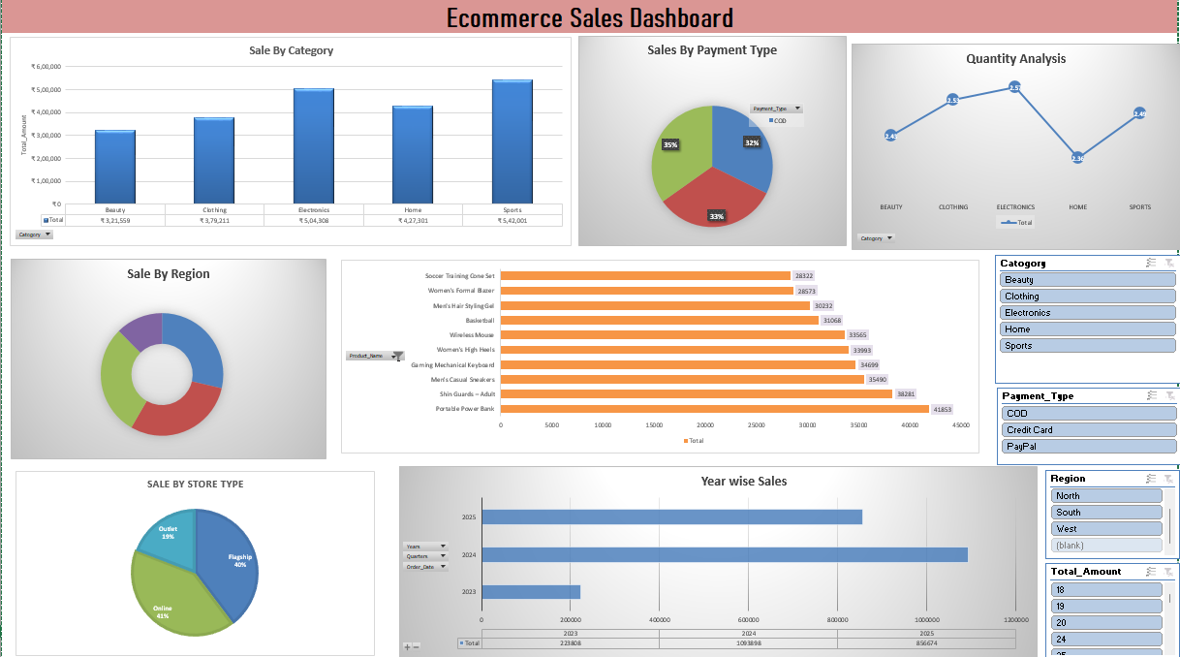

BUSINESS RECOMMENDATIONS:
- Focus on high-performing categories like Sports and Electronics
- Improve sales in low-performing categories like Beauty
- Promote top-selling products to maximize revenue
- Analyze regions with lower sales for growth opportunities
- Optimize pricing and discount strategies
CONCLUSION:
This project demonstrates end-to-end data analysis using Excel, including data cleaning, transformation, analysis, and dashboard creation to derive meaningful business insights.

